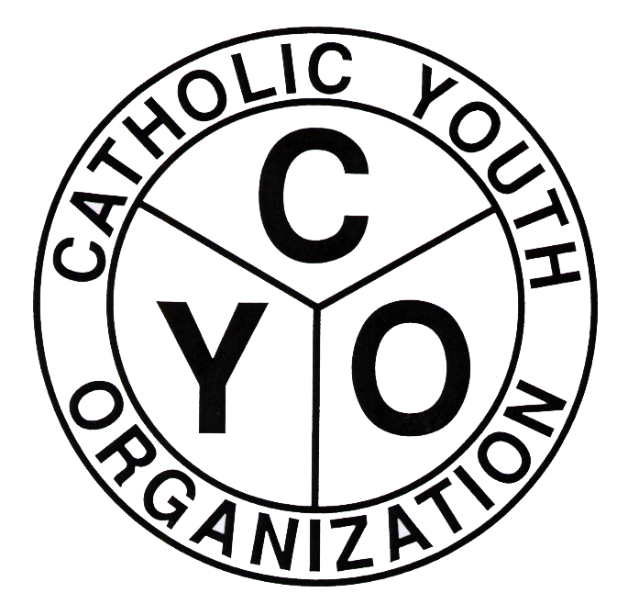
Catholic Youth Organization
of the Diocese of Brooklyn
7200 Douglaston Pkwy. Douglaston NY 11362
Tel.: 718.281.9550

BASEBALL Field Availability Form

Location of Home Field ______________________________
____________________________________________________
Surface____________Length_______Width_______
Is a parking lot adjacent and available at no cost (Y/N)
If not a Parish field, who is owner of the facility
(ex. NYC Dept. of Ed, NYC Parks Dept., etc.)
_____________________________________________________
Is there a permit required (Y/N)
If so, please attach copy of permit to this form.
The field is available for CYO games on
Fridays 1st game starting________last game starting_______________
Not available on these Fridays_____________________________
Saturdays 1st game starting________last game starting_______________
Not available on these Saturdays___________________________
Sundays 1st game starting________last game starting _______________
Not available on these Sundays____________________________

Available weekday dates
Date_________ 1st game starting_______last game starting ____________
Date_________ 1st game starting_______last game starting ____________
Date_________ 1st game starting_______last game starting ____________
Date_________ 1st game starting_______last game starting ____________
Date_________ 1st game starting_______last game starting ____________
Date_________ 1st game starting_______last game starting ____________
Date_________ 1st game starting_______last game starting ____________
Date_________ 1st game starting_______last game starting ____________
Date_________ 1st game starting_______last game starting ____________

Comments:________________________________________________________________________________________________________________________________________________________________________________________________

